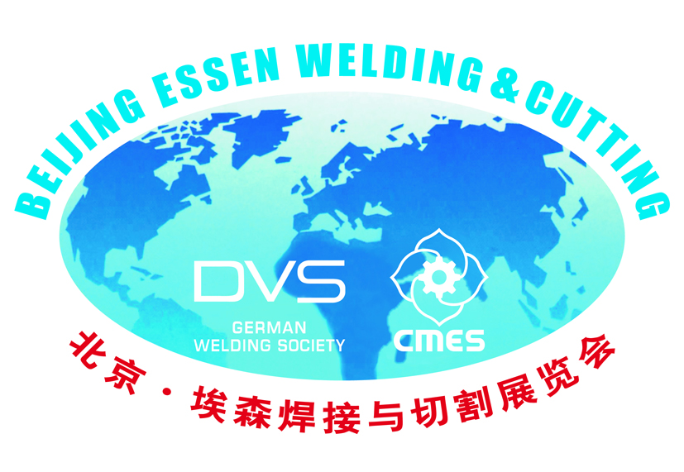
Beijing Essen Welding & Cutting Fair 2020
June 2-5, 2020
Shenzhen World Exhibition & Convention Center（Deadline: Jan.25, 2020）
Space Application Form
We hereby apply for the participation in Beijing Essen Welding & Cutting Fair 2020 and accept the Exhibition Rules.
- Applicant
Company Name
in English
Company Name
in Chinese
Address |  |  |  |  | Zip Code
Contact Person |  | Position
Telephone |  | Fax
E-mail |  | Website
Signature  & Date |  | Other Contact Information
Products
- Booth Options (Payment with either US dollar or Euro is acceptable!)
Type of Booth | Price(￥/m²) | Area | Total Booth Fee  (CNY/￥)
Package Booth Min. (9 m²) | ￥1800 | ( )m×( ) m
Raw Space Min. (36m²) | ￥1600 | ( )m×( ) m
Booth price for Raw Space includes space, pre-exhibition promotion, free invitations for exhibitors to invite their own customers and basic entry in Show Directory.
For Package Booth, the price covers the additional provision of partition boards, carpeting, company name both in Chinese and English on the fascia board, two spotlights, one socket of 220V/5A(power below 500W), two white folding chairs, one information counter, and one wastepaper basket for each 9 square meters.
- Participation Procedure
Sending the signed Application Form →→Receiving our confirmation →→Accepting your booth location→→ Paying the booth fee→→ Preparing according to the Exhibitor Manual for exhibiting
- Payment & Terms
Total booth fee shall be paid after booth location is confirmed. Booth reservation will not be effective unless the total booth fee is paid. Upon cancellation of reservation later than 90 days before the show opening, 50% of the total booth fee will be non-refundable. Upon cancellation later than 45 days before the show opening, the total booth fee will be forfeited.
- Space Assignment Policy
The following criteria are applied in booth location assignments:
  - Space requirements and exhibits’ size (to assure optimum utilization of available space, large space will be assigned first).
  - Date of the application received by the Organizer (Space will be allocated on a first-come-first-served basis).
  - The exhibition area should be a multiple of 9 sqm.
Please fax or e-mail the Application Form to any of the following offices:
China Ctc: (Ms.) Yuan Yi
Chinese Mechanical Engineering Society
2-5-1607 Lianhuaxiaoqu, Haidian District, Beijing, 100036, P.R. China
Tel: +86-10-63983928,63972304, Fax: +86-10-63980554 E-mail: yuany@cmes.org
Europe India Russia Brazil Ctc: Lei Zhang or Torben Brinkmann
Messe Essen GmbH
Postfach 10 01 65, D-45001, Essen, Germany
Tel: +49-201-7244 727Fax: +49-201-7244 513
E-mail: Lei.Zhang@messe-essen.de or Torben.Brinkmann@messe-essen.de

America Ctc: Matthew Rubin
American Welding Society
8669 NW 36th St, #130, Miami, FL 33166-6672, USA
Tel: +1-800-443 9353 ext. 297 Fax: +1-937-667 0438 E-mail: mrubin@aws.org

Korea Ctc: SeungKwan, Kang
KOREA WELDING INDUSTRY COOPERATIVE
Valley 702~703ho, Gasan digital 1-ro 1ho, Geumcheon-gu, Seoul, 153-803, Korea
Tel.+82-2-785 5504~6 Fax.+82-2-785 3586 E-mail: skkang@kwic.or.kr

Japan Ctc: Kimihito Hotani
Sanpo Publicaitions, Inc.
1-11 Kanda Sakuma-cho Chiyoda-ku, Tokyo 101-0025, Japan
Tel: +81-3-3258-6411 Fax: +81-3-3258-6430 Email: hotani@sanpo-pub.co.jp

